Welcome to the third segment of Getting Started with Google Suite. By the end of this segment, you should be able to explain how to access Google Documents, be able to demonstrate the basics of how to use Google Documents, and be able to explain the two main ways to work with Google Documents offline.

**How to access Google Documents?**

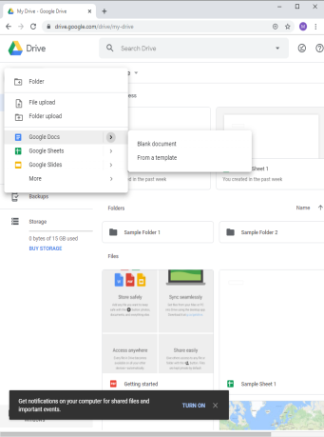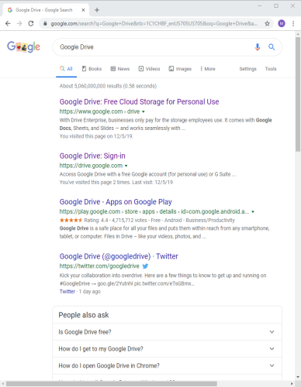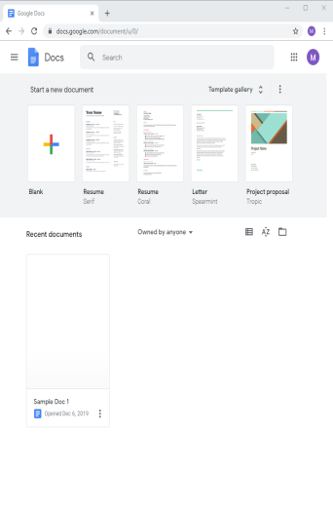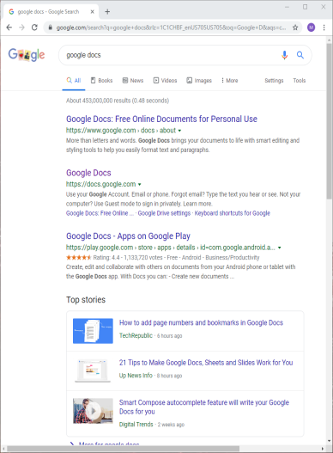There are two ways to access Google Documents depending on what you are looking for. The first is to go to Google Documents. To do this: Open Chrome, click in the address bar at the top and type in “Google Docs” and hit enter. In the search results that come up click on the second link that says “Google Docs”. Using this route will allow you to easily access the template gallery and see what the templates look like without taking an extra step. The downside is that it will auto-create the file in your main Google Drive, which can create file chaos if you do not take time to organize it.

The second way to access Google Documents is to go through Google Drive. To do this: Open Chrome, click in the address bar at the top and type in “Google Drive” and hit enter. Click on the “Google Drive” that pops up in the search and it will take you to your Drive. Then click on the “New” button in the top left corner, go down to Google Docs, hover your mouse over the right arrow and choose between creating a “Blank Document” or “From a Template”. Using this route will allow you to create in the folder where you want it to be, in turn keeping things organized. It also allows you to access the template gallery but does take an extra step with being able to view and choose the one you want to use.

**How to get started with Google Documents**

For those that have used Microsoft Word using Google Documents will be very similar with just a few formatting options located in different places. Becoming proficient in Google Documents will be just like becoming proficient in Microsoft Word right after they release a new edition where they moved all the buttons. For those that are not familiar with Microsoft Word then, good news, Google Documents is easy to learn the basics.

By the end of this section you should know how to rename a file and know where to go to effect the text type, font, size, color, and position.

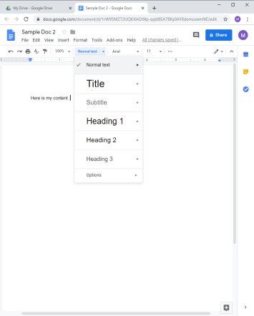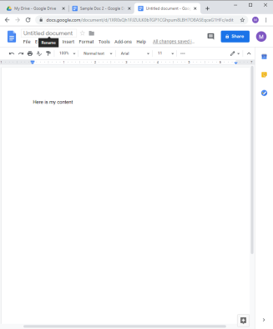 Once you have a blank document open you are already set up to type your content. So you can just start type. When you are done and would like to move onto formatting then the first thing you want to do is change the Title of the Documents. To do this click up on the “Untitled Document”, it will take the first couple words of your document and make it the title automatic. Go ahead and erase this and type in what you would like the title and the file name to be, as they are synonyms in this case.

If you would like to change the type of text highlight the text you wish to effect, click up on the top where it says “Normal Text” which will open a dropdown menu and chose which type of text to change it to. Generally, I like making the first line of a document the title of the document and will set it to a title type of text.

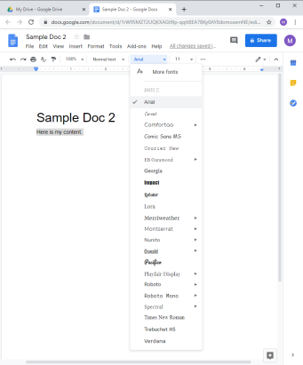 If you would like to change the font of text then highlight the text you wish to work with, click up on the top where it says “Arial” which will open a dropdown menu, and chose which font of text to change it to. The typical fonts used are Arial and Times New Roman.

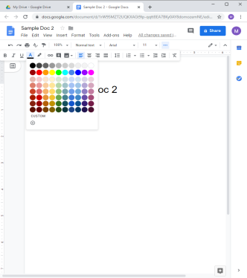If you would like to change the size of the text then highlight the text you would like to work with, click up on the top where it says “11” which will open a dropdown menu, and chose which size you would like to change it to. The standard sizes for printing that are readable to most are sizes 10, 11, and 12. Next to the size option are the special effect for the text, Bolding, Italicizing, and Underlining.

If you would like to change the color of the text then highlight the text you would like to work with, then up on the top click on where it has an “A” with a thick black line under it which will open a dropdown menu, and chose which color you would like to change it to. Next to the text color is a highlighter pen that would allow you to highlight text without changing its base color.

If you would like to change the position of your text then highlight the text you wish to effect, and then click up on the top one of the align buttons. That is all for the basics need to get started creating with Google Documents.

**How to Work with Google Documents Off-line**

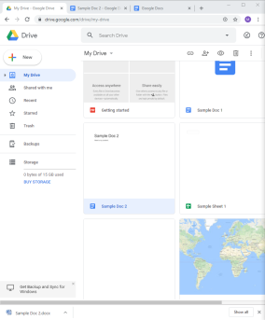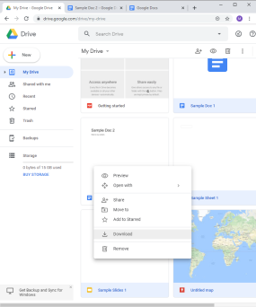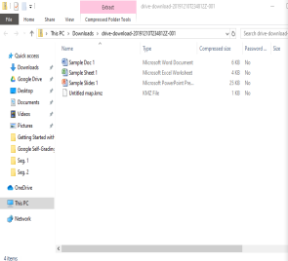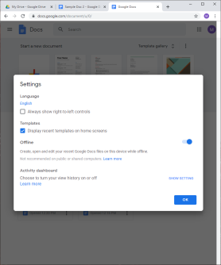 If you ever need to work off-line yet the file you need to work with is a Google Document don’t worry you have a couple of options. One option, which if you are staying on the same computer would probably be the best, is to turn on off-line mode. To do this: Open Chrome, click in the address bar at the top and type in “Google Docs”, hit enter. In the search results that come up click on the second link “Google Docs”. Then in the top left-hand corner click on the triple-stacked lines, click “Settings” and make sure that the slider next to Offline is blue. WARNING this only works with your recent Google Document files so you need to make sure that you have opened what you want to work with on the same day as you are planning on going offline.

The second option would be to download any Google Document that you want to work with as a Word Document, edit as needed and then when you have internet back upload them and convert them back to a Google Document. There are two ways to do this. If you are just planning on working with a single file then go to your Google Drive, locate the file, right-click on the file and select download. Once the file downloads, it will show up in the bottom left-hand corner of your screen. Go ahead and open the file and save it to a location you will be able to find it again. Suggestions would be either the “Desktop” or “My Documents.” If you are planning on downloading multiples files then the easiest way would be to select all of the files either by selecting the first file pressing and holding the shift key and then selecting the last file if they are in order or by selecting the first file, pressing the control key and then selecting the next file if they are not in order. Once the files are selected release the shift or control key, right-click, and click on “download.” A little box will pop up in the bottom right-hand corner to show you the progress, and then once the files have been downloaded a folder will pop up in the bottom left-hand corner. You are going to want to click on it then select all of the files you downloaded and drag them to a location where you will be able to find them again. Suggestions would be either the “Desktop” or “My Documents.”

This concludes this segment of Getting Started with Google Suite. By now you should be able to explain how to access Google Documents, be able to demonstrate the basics of how to use Google Documents, and be able to explain the two main ways to work with Google Documents offline.

Next segment will be about Google Slides.